Electrical Challenge: CAN Node Daughterboard
Name: Douglas Gray

Rules
FSUK T11.7 Low Voltage Batteries
FSUK T11.7.12 “Must include overtemperature protection of at least 30 % of the cells, meeting EV5.8.4, that trips when any cell leaves the allowed temperature range according to the manufacturer’s datasheet, but not more than 60°C, for more than 1s and disconnects the battery,”, “It must be possible to display all cell voltages and measured temperatures, e.g. by connecting a laptop, Signals needed to fulfil these requirements are SCS, see T11.9.”
FSUK T11.9 System Critical Signal
FSUK T11.9.7 “The ESF must contain a detailed description of all the potential failure modes that can occur for each SCS, the strategy that is used to detect these failures and the tests that have been conducted to prove that the detection strategy works. The failures to be considered must include but are not limited to the failure of sensors and actuators, signals being out of range, corruption of the message and loss of messages and the associated time outs.”
FSUK T11.12 Sensors & Electrical Components Mounting
FSUK T11.12.1 “[AS T11.12.1 IN 2026 FORMULA STUDENT GERMANY RULES V1.1 WITH THE FOLLOWING ADDITION] For all mounts, T2.2.3 applies.”
FSG T2.2.3 Does not seem to exist? I can’t find it in the rules document, there is a T2.2.2 but then it goes directly into T2.3 after that? FSUK also does not have a T2.2.3 so I assume this is just a typo in the rules? FSG Section T2 (General Design Guidance) doesn’t have a particular section for electrical components as FSUK does, so I’ll assume it was meant to reference FSG T2.2, which is Ground clearance.
FSG T11.12 Sensors, Cameras & Electrical Components Mounting should cover this?

FSG T11.9 System Critical Signal (SCS)
FSG T11.9.2 “Any of the following SCS single failures must result in a safe state of all connected systems:
(a) Failures of signals transmitted by cable: • Open circuit • Short circuit to ground
(b) Failures of analog sensor signals transmitted by cable: • Short circuit to supply voltage
(c) Failures of sensor signals used in programmable devices: • Implausibility due to out of range signals, e.g. mechanically impossible angle of an angle sensor.
(d) Failures of digitally transmitted signals by cable or wireless: • Data corruption (e.g. checked by a checksum) • Loss and delay of messages (e.g. checked by transmission time outs)
Signals might be a member of multiple signal classes, e.g. analog signals transmitted by cable might be a member of T11.9.2.a, T11.9.2.b and T11.9.2.c.”
FSG CV4.1 Shutdown Circuit
CV4.1.1 “The Shutdown Circuit (SDC) directly controls all electric power to the ignition, fuel injectors and all fuel pumps. It must act through a minimum of two mechanical relays.”

2. Overview
The rules I researched related to the restrictions with mounting sensors/electrical components, and how they must transfer data through the system for critical signals. As the task does not specify where this temperature sensor will be placed in the car, I also researched rules relating to possible locations that would require one.
FSUK T11.7 – Over-temp for longer than 1s must trip something to disconnect the battery, and the measured temperature must be able to be displayed by connecting a laptop. This would likely be handled by other systems rather than the sensor itself, but is worth noting.
FSUK & FSG T11.9 – System Critical Signal failures, which this temperature could be depending on the install location, have to be carefully considered for multiple ways they could fail, i.e. corruption, packet loss, physical sensor failure, etc.
FSG CV4.1 may be triggered by the above SCS, so I included a short excerpt from that section to have a reference for it.
[Write your overview here as described in the challenge instructions. Only a short paragraph is needed]

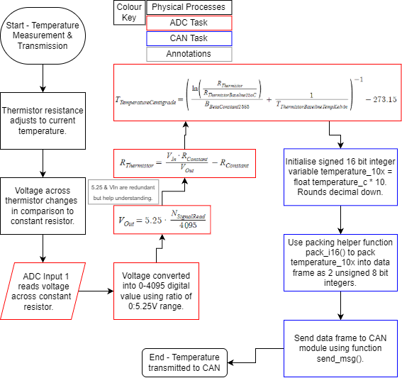
3. Logic/block diagram

Desmos Graph to model the inputs, constants, and ‘outputs’ for the ADC task processes:
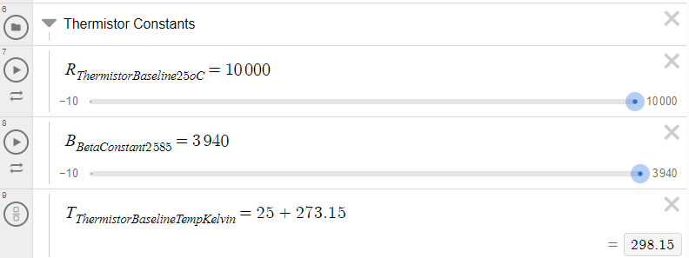
https://www.desmos.com/calculator/gdqgglfel8
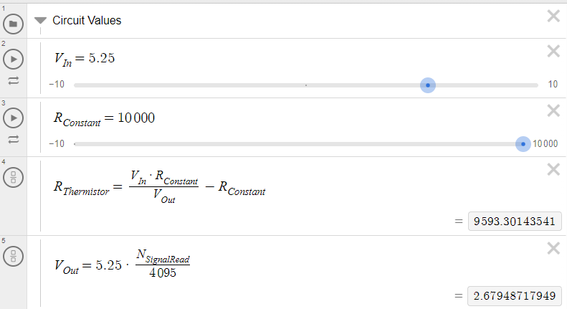
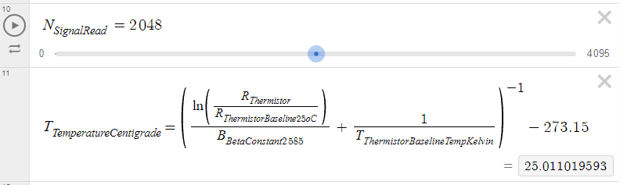
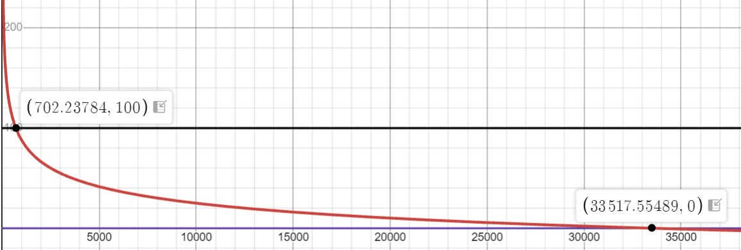
A graph of temperature against resistance for the specified thermistor. Points are the edge values for the range 0-100ºC.
[Include your logic/block diagram for the BSPD here, along with a written description]

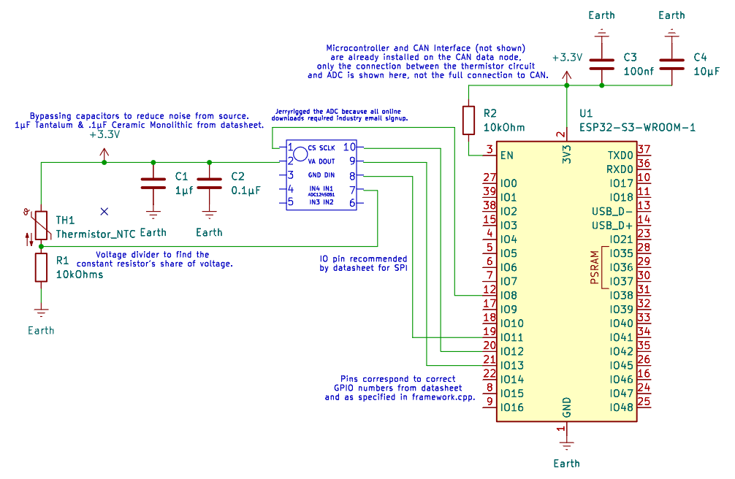
4. Schematic Design
The schematic includes 3 primary elements as follows:
Voltage Divider
A simple voltage divider to find the voltage across the 10kOhm constant resistor against the variable resistance of the NTC thermistor. The V_{out} from this goes to the input pin of the ADC to be converted into a digital signal.

Analogue Digital Converter
The ADC takes input on only 1 pin of the voltage across the constant resistor and translates it into a 12 bit signal. It is powered in parallel to the voltage divider from a 3.3V source, within it’s operating range, with the recommended capacitors from the datasheet in place performing power bypassing to ensure any noise from the power source does not interfere.
The chip select, clock and data output and input pins are all connected to the microcontroller to the correct GPIO pins as specified in framework.cpp from the template code and the microcontrollers datasheet. This ensures that it stays in sync and can be called to with the read_adc() function.

Microcontroller
Powered by a separate 3.3V power source, also using capacitors to reduce noise from the source, and with a 10kOhm pull up resistor to provide a high signal to the EN pin so that it turns on properly.
As stated in the brief, the microcontroller is already integrated into the CAN node with a CAN interface, so in order to keep the schematic clear I have not detailed this.
[In this section include your screenshot of your schematic. Ensure that the schematic is large enough to be easily readable on a laptop screen - this may require a full page. Also include the description of your schematic here, giving as much detail as you feel is necessary to explain it]

5. Software
ADC Task:
#include "challenge.h"
#include <cmath>

// Runs once a second. read_adc() gives you a number from 0 to 4095.
bool adc_read(float &temperature_c)
{
const float raw_adc = read_adc();
if (!std::isfinite(raw_adc)) return false;
temperature_c = NAN;

//Circuit & Thermistor Constants
//RCon - Resistance of constant resistance comparator resistor in the voltage divider against the thermistor.
//RThe - Datasheet resistance of thermistor at a temperature of 25 degrees celsius.
//BetaCon - Datasheet beta constant of thermistor between temps of 25 to 85 degrees celsius, used to calculate temperature from resistance.
//ThermistorBaselineTemp - Temperature in kelvin (required for temp calculations) at which thermistor reaches its baseline resistance.
const float RConstant = 10000.0, RThermistor25Baseline = 10000.0;
const float BetaConstant2585 = 3940.0;
const float ThermistorBaselineTempKelvin = 25.0 + 273.15;

//float VOut = 5.25 * raw_adc / 4095.0, simplified steps from flowchart diagram but line here for clarity.
float RThermistor = RConstant * 4095 / raw_adc - RConstant;
//Temperature calculated using Beta Parameter Model (sufficient for this application over Steinhart-Hart model as lacking required measurements and level of precision not required.)
//cmath power and natural log used, optimised math performance by performing minimal amount of resource intensive exponentiation and logarithms.
temperature_c = pow(((log(RThermistor / RThermistor25Baseline) / BetaConstant2585) + pow(ThermistorBaselineTempKelvin, -1)), -1) - 273.15;

//Maths code tested seperately outputs expected value for different raw_adcs.

return std::isfinite(temperature_c);
}

//File size is 2KB, should fit easily within Microcontroller's ROM capacity of 384KB.

CAN Task
#include "challenge.h"
#include "MSM_CAN.hpp"
#include <cmath>

// Pack temperature_c multiplied by 10, then send the message.
void can_send_temperature(float temperature_c)
{
MSM_CAN::TxFrame frame{};
frame.id = 0x600;
frame.length = 2;

//integer 10x value of temperature_c, will always round down at 1dp (25.19 -> 251), level of precision is acceptable.
int16_t temperature_10x = temperature_c * 10;
//Convert to 16 bit signed, split into 2 bytes for payload prep. Frame uses unsigned int, convert signed directly and CAN will change it back?

//Packing helper for int16_t -> uint8_t (from MSM_CAN.hpp):
//inline void pack_i16(uint8_t data[8], uint8_t index, int16_t value) //helper function to pack uint8_t data[8] with a big-endian encoded int16_t
//{
// pack_u16(data, index, static_cast<uint16_t>(value));
//}
MSM_CAN::pack_i16(frame.data, 1, temperature_10x);
MSM_CAN::send_msg(frame);
// Could be better to use schedule() instead of send_msg() as this would allow us to send the data periodically every second (as the brief states)
}

[In this section include the code you came up with for the daughterboard. We recommend coming into the interview with the code on your IDE as well as we may ask follow-up questions. Make sure that the code is visible and clear, this can take up as much space as you require for clarity. Explain any key decisions you made through comments, explaining your thought process thoroughly]

6. Implementation
[Here you can discuss the implementation process of your design, as described in the challenge description. Provide as much detail as you need to explain your vision of implementation]

